***Marketing Insight Data Analyst***

**SQL Challenge**

The SQL challenge consists of 3 questions all relating to the datasets provided. Please complete all 3 questions and send the answers through once you have completed the challenge and have reached the satisfactory result in the outputs.

Data necessary for the analysis:

* -  user_visits.sql
* -  leadouts.sql

**Task 1**

Write a query that would provide a summary of earnings for each marketing channel for the month of January.

**Task 2**

Identify the marketing channel and the partner_shops that have daily earnings of less than 50 euros a day that occur over a weekend (Saturday, Sunday)

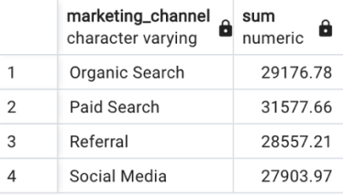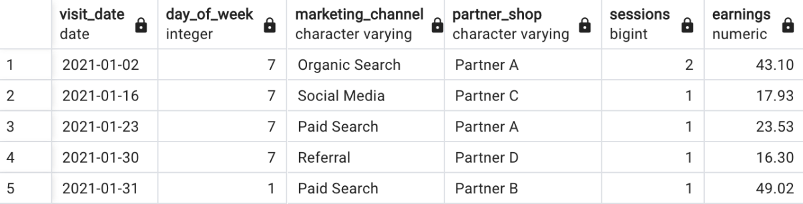

**Task 3**

Write a query that would identify how successful each marketing channel is through the first session by identifying how many unique sessions translate into a leadout to a partner.

**Output**

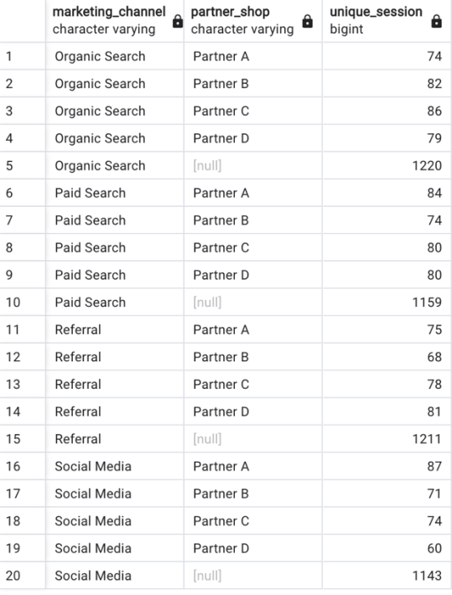

**Test case Scenario**

Our company has just started a big push for brand awareness through marketing campaigns in combination with strong performance marketing campaigns to push sales. The marketing department has launched various initiatives across different channels. The biggest one in terms of budget is the nationwide TV advertising campaign that runs 4 different spots on all TV channels. In addition to that, they took part of the video budget and bought slots on YouTube. To accompany the brand initiative, idealo spending for performance marketing channels were increased a lot in order to support the brand initiatives.

**Task 1**

Before even looking at data, please formulate your thoughts on that scenario. From your experience, what are the major challenges with tracking success in such a setup and how best to approach them in order to get meaningful results anyway? Please prepare any relevant examples you could cite from your previous experience. Please comment on each of the campaign types mentioned in the scenario individually and on the overall combination.

**Task 2**

You are now given 15 months' worth of data on basic business metrics like number of daily visits (sessions), page impressions, conversions, earnings, cost etc.  
The data is based on actual data you might pull from our data lake for this analysis, although it has been scrambled to protect our real numbers. There’s no hidden bad entries or bugs in it, you can treat it as ready to analyse.

It also contains information on marketing channels, but nothing that would explicitly attribute numbers to the running brand campaign. All you know is that the campaigns all launched on the first of March 2020 and that the brand marketing budget spent was 2.0 Mio €.  
Please answer following questions:

* -  Is there a visible impact of the TV campaign on any of the marketing channels? If yes, how big is it? If no, what could be the reasons for that / what should we improve asap?
* -  You need to give a recommendation to the management about how to allocate budgets for brand and performance for the rest of the year 2020. You have 10 Mio for July to December. Would you recommend increasing budgets for brand or performance campaigns? Or neither? Why?

**Help**

Whenever you feel you miss information please make assumptions and be prepared to present and explain them.  
We cluster channels in performance channels (no idealo specific definition) brand (no idealo specific definition) and organic (Direct Generic, SEO Generic, CRM, Social & Referral)